EXAMPLE OF A QUALITY STUDENT BUSINESS PLAN
Busad 101

One Page Business Plan: Product

- Vision

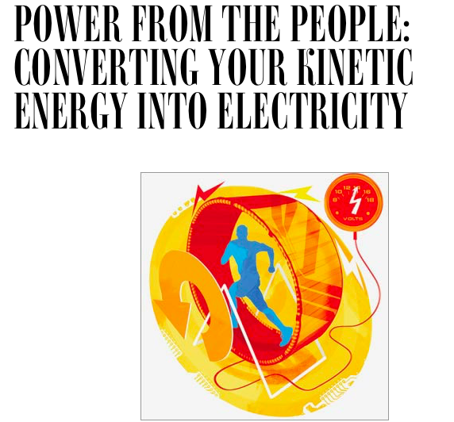
(image from wired.com)

My grand plan is to innovate and revolutionize the way we use our own energy, and our pursuit of fitness. Gyms and sports centers around the world have an abundance of kinetic energy from people exercising that can be harnessed and converted into electrical power (similar to a windmill or turbines), yet the current gym equipment does not have the capacity to do this conversion. Plenty of people are joining the fitness lifestyle which means a lot of kinetic energy being produced by every single person working out, that is not being harnessed and just being wasted.

My business idea is to create gyms and individual gym equipment that are wirelessly able to harness energy produced from people exercising and use it to power anything from small appliances, charging cell phones, to completely powering up an entire building.

A whole gym could even be used to power places remotely, like in 3rd world countries. Individual treadmills or ellipticals can be purchased for the home or office to power devices. A bonus incentive of the internet or Netflix only working when the machine is in use.

I plan on growing the business by having a technology R&D department and manufacturing our own gym equipment, and providing an add-on modification device to existing equipment for customers who already have their own. I also plan on signing contracts with gyms, hotels, airports, and corporate offices to buy my product in bulk and use it in their businesses. I do eventually plan on going public and selling shares on a stock exchange.

Example of current research and my R&D Department’s objectives, from Wired.com

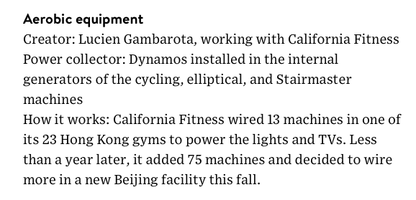

- Business Overview (Mission)

I will be selling gym equipment (treadmills, elliptical machines, rowing machines, etc) that convert kinetic energy into electricity that can power devices and appliances.

My target market are health-conscious people as well as environmentally-conscious people. People who are already paying for gym memberships, athletes, anyone and everyone who are able to move and want to save the environment and be healthier. It is also a morale boost to have the instant gratification of powering up Netflix as a reward for moving, which would benefit those struggling with exercise motivation or those recovering with physical therapy.

I will sell my products online, through storefronts, and through catalogs. My products will be shipped.

- Pricing Strategy

I will price my products in a tiered fashion. A lower model will cost $800 and one with more features will be around $1200. Compared to the market, the average treadmill costs anywhere from $200 to $2000. I wanted a price that was accessible to customers, but still showed the value of a high-end product. My competitive pricing will lure customers from the competition because it is not too big of a jump price-wise, yet the value they get offers so much more as far as the new technology that the competition doesn’t have. The new kind of technology I will offer stands out from the crowd, and the brand image of my company will appeal to people’s ethics and values of saving the earth and living a healthy lifestyle at the same time, therefore building brand loyalty.

MODEL | PRICE | COMPETITION | FEATURES
Basic | $900 per unit | $200-800 | Basic equipment with energy conversion to power small appliances
Premiere | $1300 per unit | $900-2000 | Energy conversion to power bigger appliances or multiple small ones, internet and Netflix available

- Advertising and Promotion

My marketing strategy involves using a business website, email, social media, facebook marketing, and google ads. I will also advertise in guest segments in talk shows or podcasts, as well as celebrity endorsements by people like Richard Branson, Elon Musk, and Oprah. I will be collaborating with existing companies like gyms, hotels, and airports, like marketing on their commercials in the plane before takeoff and the plane magazine, having a sample treadmill/charger in the airport lounges and hotel gyms and country clubs. Maybe even do sponsorships for the Olympics.

Marketing materials will be digital flyers and online ads, commercials, as well as digital billboards on Time Square, etc to reduce paper waste and live the company’s message of saving the environment by reducing waste.

Customer feedback will be generated directly through a survey on the treadmill screen, right after they have used it. Testimonials will also be gathered through social media, referrals, and the celebrity endorsements.

Sample promotion from existing (potential partner) company, The Green Microgym:
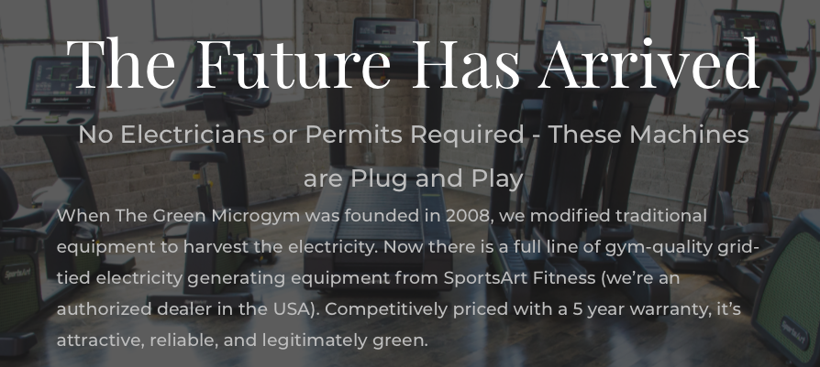

- Objectives

TIMELINE | GOAL | TOTAL
Quarter 1 | Sell 20 units to 5 gyms | 100 units total
Quarter 1 | Sell 10 units to 10 hotels | 100 units total
Quarter 1 | Sell 10 units to 10 airports | 100 units total
Quarter 2 | Sell 40 units to 10 gyms | 400 units total
Quarter 2 | Sell 20 units to 20 hotels | 400 units total
Quarter 2 | Sell 29 units to 20 airports | 400 units total

Keep doubling the number as time goes and product value is proven.

Have five big names who model my company values using my product in their home/office in the first six months (Richard Branson, Elon Musk, Oprah, Obama, Leonardo diCaprio, Paul McCartney, Michelle Obama, etc – gifted products, not sold)

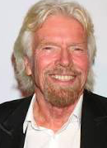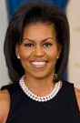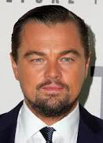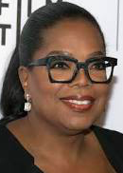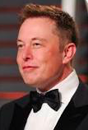

Obstacles that may prevent these: Developers and manufacturers not able to deliver sufficient product technology, funding delays due to newness and uniqueness of the product and industry niche, and traction with getting people to join the movement.

VI. Action Plans

TIMELINE | ACTION
By August 2019 | Have technology R&D team assembled and start working on equipment.
By January 2020 | Have first prototypes ready for testing and safety checks.
By March 2020 | Have contracts with manufacturers, investors, wholesalers, and government grants negotiated and signed.
By April 2020 | Have company website up and send first products out to celebrity endorsers and big names.
By May 2020 | Have full blown marketing strategy in effect to the public.
By June 2020 | Open to taking orders and have products ready and stocked for official launch.
By July 2020 | Official opening launch party and unveiling of first gym to the public. Open for business.

Obstacles or concerns:

Technology R&D team not developing product fast enough for the timeline = Hire extra help and find more investors for more resources.

Possible troubleshooting for product malfunction = test and retest for safety and functionality over and over to be 100% sure.

The public not jumping on the movement when product is revealed = need to get more influential people to provide testimonials.

Trouble breaking through international barrier = work with organizations helping 3rd world countries first to show the global impact my products could provide.

