Practice Test # 3 fall 2020

Key terms
Fixed cost
Variable cost
Total cost
Average variable cost
Average fixed cost
Returns to scale
Implicit costs
Explicit costs
Shutdown rule
Profit maximization rule
Marginal cost
Economic profit
Accounting profit
Competitive market characteristics

1 . Explain why economies of scale are a long run, not a short run decision.
2. Given the following information, complete a table showing:
Q (weddings served) ATC MC_ TC
0 x
1
2
3
4
Lease on building = $2000 Employees in your restaurant = $500/meal; Your time spent running the restaurant = $200/wedding; Food for restaurant = $800/wedding; Your capital invested in the restaurant = $1000;
3. In the example above, which are implicit costs and which are explicit costs?
4. What is happening in the following situation with regard to the scale of production?

Small production unit Large production unit
Q FC VC Q FC VC
10 40 40 100 300 500
20 100 200 900
30 200 300 2100

5. Give a real life example of an implicit fixed cost and an explicit variable cost. Explain briefly your reasoning.

6. Average fixed costs and average variable costs differ as a business expands. How? And why is this important?

7. What mistake might a business make if it confuses marginal cost and average cost?

8. Jessica wants to expand her business and use the 10 acre property she owns and rents to a local sheep rancher for $10,000/year, to build a mall for $4 million. What are the implicit costs and why are they important?

9. A used car dealership had sales revenues of $2 million last year. It spent $1.2 million on labor, $250,000 on capital and $400,000 on materials. What was the dealership’s accounting profit? Why does it differ from economic profit?

10. Will accounting profit be higher or lower than economic profit? Why?

11. Aabir, a milk farmer, earns $300,000/month in revenue. His monthly costs include: Administrative cost: $40,000. Feed: $60,000. Equipment and maintenance: $40,000. Labor: $70,000. Transportation: $10,000. Miscellaneous: $20,000. Foregone rent for the land used for cattle grazing $10,000. Value of his son’s time that helps on weekends: $2,000. Owner’s salary: $10,000. Aabir's accounting and economic profit respectively are what?

12. As production increases what happens to average fixed cost? Why?

13. What do A, B and C tell us in the following graph? Why is each important?
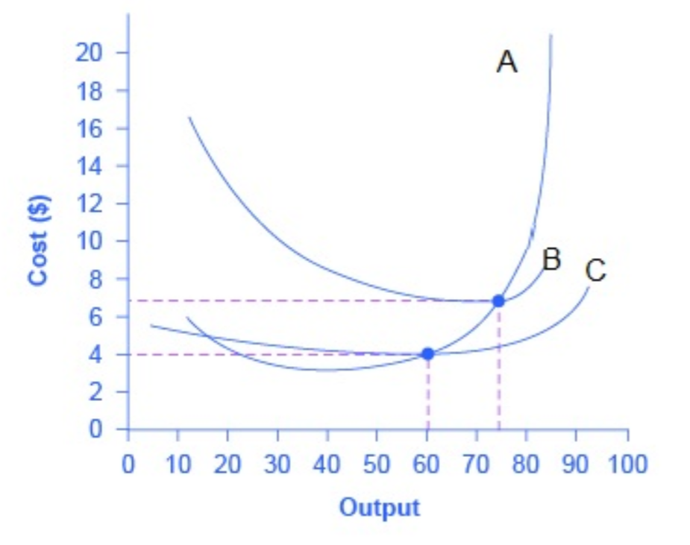

14. Pilar bought an old truck to start his food truck business for $10,000 and spent another $5,000 to repair and upgrade it. Pilar’s friend argues that his business is not worth his time since his revenue of about $2,000 per day does not cover the purchase and repair costs of the truck. How do you respond?

15. When a business has some form of sunk costs, how should the business use the value of these sunk costs in making decisions?
‘
16. Which of the following are conditions of perfect competition? Why?
- All firms sell identical products.
- There are few buyers and sellers.
- Consumers have little relevant information to make rational buying decisions.
- 17. What is happening to this business?
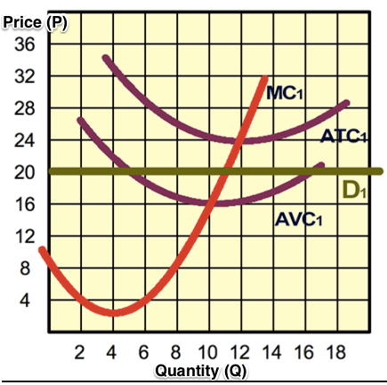

18. What is happening to this business?
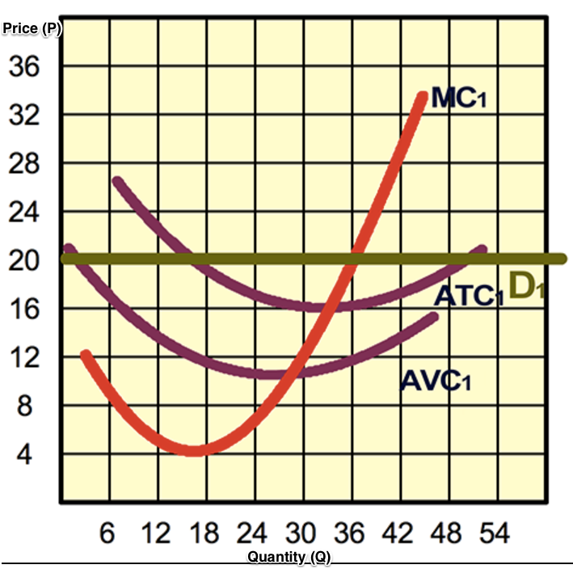

19. In a perfectly competitive market, a firm finds that at its MR=MC output level, the Total Variable Cost (TVC) equals $550, Total Fixed Cost (TFC) equals $250, and Total Revenue equals $700. The firm should do what?

