Practice Test # 4 Spring 2021

Key terms

Monopoly
Natural monopoly
Barriers to entry
Economies of scale
Price discrimination
Legal monopoly
Profit maximization
Marginal revenue= marginal cost
Inefficiency of monopoly
Shut down
Conglomerate merger
Horizontal merger
Vertical merger
HHI
Concentration index
Antitrust law

Tacit collusion
Competitive market
Oligopoly market structure
Monopolistically competitive market structure
Product differentiation
Game theory

1. Give a real life example of a vertical merger and a conglomerate merger. Why aren’t these mergers as likely to be investigated by the US Department of Justice? Nonetheless, what possible problems do they present for consumers?

2. What are the relative advantages of buying a good or service produced by a firm in an oligopoly market structure versus the relative advantages of buying a good or service by a firm in a monopolistically competitive market structure?

4. Draw a two firm game theory matrix in which each firm has the choice of offering a discount or not offering a discount. In the matrix make up numbers for each firm’s profits so that there is a dominant outcome that both firms offer the discount.

5. In the following matrix for the profits of two pizza firms with the decision whether or not to offer “free delivery” what is the dominant outcome. Explain why.

 | You deliver | You don’t deliver
Rival delivers | Rival gets $3000  You get $3000 | Rival gets $5000  You get $2000
Rival doesn’t deliver | Rival gets $2000  You get $5000 | Rival gets $4000  You get $4000

6. In the following matrix, what is the dominant outcome? Why?
.
 | You advertise | You don’t advertise
Rival advertises | Rival gets $7 million  You get $7 million | Rival gets $20 million  You get $5 million
Rival doesn’t advertise | Rival gets $5 million  You get $20 million | Rival gets $12 million  You get $12 million

7. Would you expect prices to rise if a formerly monopolistically competitive nail salon market was turned into a chain franchise with an oligopolistic market structure? Why?

8 Why is tacit collusion especially likely in an oligopoly but not in other market structures?

9 In a monopolistically competitive market, use a diagram to show what will happen to profits, output, profits and efficiency in the long run.

10 Given the following information, what do you recommend as the price for this firm? Be as accurate as you can. Please show your work
Q Price TC MC
0 $ 8
$4
- $20
7
- $ 16
10
- $14
16
- $12

11 Explain in words what price discrimination does to profits and quantity and explain why.
- Why might a monopoly continue production even if It has a loss? Then, in words, explain when this might occur in the real world.
- In a natural monopoly, government regulation usually is needed. Explain why in words.

- Will a firm be happy if marginal revenue is greater than marginal cost? What should it do? Why?

- Using a real life example, explain why price discrimination is difficult to accomplish.
16. Given the following information:
Price $90 Quantity demanded 1
Price $70 Quantity demanded 2
Price $50 Quantity demanded 3
Price $30 Quantity demanded 4
And the fixed cost for her business is $50, while it costs her $40 to paint each additional painting, how many paintings should she sell if she sells each painting for the same

17. In the follow situation for a monopoly firm in the short run, what is the profit maximizing level of output. Please show your work and be as precise as possible.
Q P FC MC______________________________________
0 $25
$5
1 $20
$6
2 $18
$7
3 $16
$8
4 $14

18. How can government regulate a natural monopoly? Why is this sometimes difficult, causing the government to directly provide the service?
19. For a monopoly, the MR curve lies ________ the demand (price curve.) Explain in words why this is true.

20. Microsoft is able to reduce the cost of software by distributing it on the internet, rather than selling it in stores, how will this change affect price, quantity and profits. Please show these results in a diagram.

21 In the following market, is there likely to be an investigation by the US Department of Justice based on the HHI if firms B and C merge? Please show your calculations.
Market share
Firm A 50%
Firm B 20%
Firm C 10%
Firm D 10%
Firm E 10%

22. In which market structure are you likely to find tacit collusion? Explain why using a real life example.

23. What is happening to the firm in each the diagrams below? What do you recommend it should do?
For each diagram, what is the TR, TC, profits?
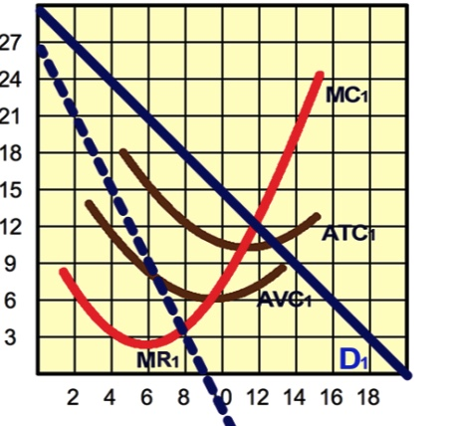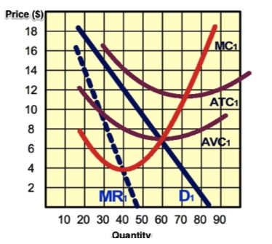
24. Using one of the examples from your team discussion, why does the group paying the higher price have a lower price elasticity of demand?

25. A friend wants to open a food truck selling Armenian food. He says right now there aren't any in the neighborhood. What do you tell him about his prospects for profits in the short run and in the long run? Why?
What do you tell him about his expected efficiency as measured by ATC in the long run? Why?

26.
In the following matrix for the profits of two dry cleaners with the decision whether or not to offer discounts for regular customers. What do expect to happen? Why? Note: they cannot collude

 | You don't offer discount | You offer discount
Rival doesn't offer discount | Rival gets $5000  You get $5000 | Rival gets $3000  You get $6000
Rival offers discount | Rival gets $6000  You get $3000 | Rival gets $4000  You get $4000

27. Match the following mergers with a merger type and, for each, explain why
Types: Horizontal, vertical, conglomerate
1. Hilton Hotels buys a laundry firm
2. American airlines buys Southwest arilines
3. Vons grocery buys Ralphs grocery
4. Starbucks buys car leadership

